**Preface**

**About Ivolador**

Ivolador is a technology company focused on Raspberry Pi and Arduino open source community development. Committed to the promotion of open source culture, we strive to bring the fun of electronics making to people all around the world and enable everyone to be a maker. Our products include learning kits, development boards, robots, sensor modules and development tools. In addition to high quality products, Ivolador also offers tutorials to help you build your own project.

**About** **Starter Kit V1.0**

This kit is suitable for Arduino Uno, Mega 2560, and Nano. All the code in this user manual is compatible with these boards.

Our Ivolador board is fully compatible with Arduino board.

You can go to website **https://github.com/Ivolador/ Ivolador Starter Kit for Arduino.** to download related code.

Note: This kit is different from other kits. All the components in this kit are provided in the form of modules which integrate some necessary components, such as comparator, resistor, and capacitor and so on. Therefore it is convenient for circuit connection.

Contents

[Components List 3](#_Toc479832465)

[Notice 11](#_Toc479832466)

[Lesson 1 Button 13](#_Toc479832467)

[Lesson 2 Flowing LED Lights 17](#_Toc479832468)

[Lesson 3 Buzzer 20](#_Toc479832469)

[Lesson 4 Controlling an LED by Potentiometer 23](#_Toc479832470)

[Lesson 5 Photoresistor 26](#_Toc479832471)

[Lesson 6 Servo 29](#_Toc479832472)

[Lesson 7 Tilt-Switch 32](#_Toc479832473)

[Lesson 8 Thermistor 35](#_Toc479832474)

[Lesson 9 Light Alarm 37](#_Toc479832475)

[Lesson 10 Automatically Tracking Light Source 40](#_Toc479832476)

Components List

|  |  |  |  |
| --- | --- | --- | --- |
| No. | Name | Qty. | Component |
| 1 | UNO R3 | 1 |  |
| 2 | USB cable | 1 |  |
| 3 | Prototype extension board | 1 |  |
| 4 | Mini breadboard | 1 |  |
| 5 | Large breadboard | 1 |  |
| 6 | 5V stepper motor |  |  |
| 7 | Servo | 1 | C:\Users\Administrator\Desktop\servo.jpg |
| 8 | 2003 stepper motor driver board |  |  |
| 9 | Red LED | 10 | 16x red led副本 |
| 9 | Green LED | 10 | 2x green led副本_副本 |
| 10 | Yellow LED | 10 | 2x green led副本_副本 |
| 11 | Flame sensor | 1 |  |
| 12 | LM35 temperature sensor | 1 |  |
| 13 | Infrared receiver | 1 |  |
| 14 | Photoresistor |  |  |
| 15 | Tilt Switch | 2 | C:\Users\Administrator\Desktop\零件\tilt sensor.jpg |
| 16 | Key cap | 4 |  |
| 17 | Key switch | 4 |  |
| 18 | Passive buzzer | 1 | _MG_7702_副本.jpg |
| 19 | Active buzzer | 1 | _MG_7701_副本.jpg |
| 20 | Remote Control | 1 |  |
| 21 | 1602 Screen | 1 |  |
| 22 | DuPont line | 1 |  |
| 23 | Breadboard line Jumper Wires | 65 | im120530005_1_副本 |
| 24 | 8\*8 dot matrix |  |  |
| 25 | One digit eight segment tube |  |  |
| 26 | Four digit eight segment tube | 1 |  |
| 27 | IC 74HC595 | 1 |  |
| 28 | Resistor (220Ω) | 10 | G:\电路图super kit\电阻\220R-1.png  (red, red, black, black, brown) |
| 29 | Resistor (1KΩ) | 10 | G:\电路图super kit\电阻\1K-1.png  (brown, black, black, brown, brown) |
| 30 | Resistor (10KΩ) | 10 | G:\电路图super kit\电阻\10K-1.png  (brown, black, black, red, brown) |
| 31 | Battery 9V | 1 |  |
| 32 | Battery Holder | 1 |  |
| 33 | 40pin pin header 2.54mm | 1 |  |
| 34 | Potentiometer | 1 | 1x Trim Pot – 50k副本 |
| 35 | CD with tutorial | 1 |  |
| 36 | Component box | 1 |  |
| 37 | plastic box | 1 |  |

**Note:**

After unpacking, please check that the number of components is correct and that all components are in good condition.

Notice

All the experiments in this kit are done with Ivolador Uno R3 board, but they are also compatible with Ivolador Mega 2560, Ivolador Nano and all official Arduino Boards. All the code included in this kit works with these boards.

So what does COMPATIBLE mean here? It means you can use any of the three boards to do the same experiment with the same wiring. Take turning on an LED as an example. We use Ivolador Uno as the microcontroller, but you can also use Ivolador Nano or Ivolador Mega 2560 to serve the same function. Just select the right Board and COM when compiling.

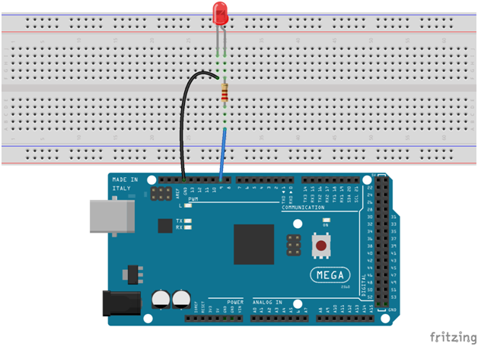

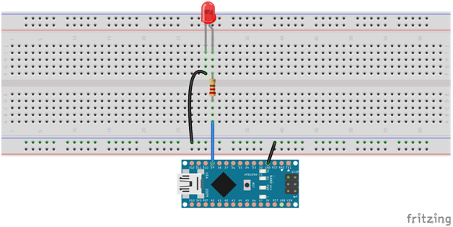

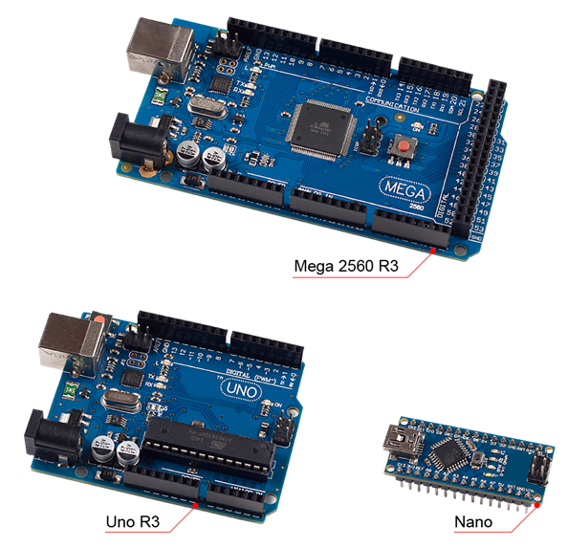

Lesson 1 Button

**Introduction**

In this experiment, you will learn how to turn on/off an LED by using an I/O port and a button. The "I/O port" refers to the INPUT and OUTPUT port. Here the INPUT port of the Ivolador Uno board is used to read the output of an external device. Since the board itself has an LED (connected to Pin 13), so you can use this LED to do this experiment for convenience.

**Components**

- 1 \* Ivolador Uno board

- 1 \* USB cable

- 1 \* Button

- 1 \* Resistor (10kΩ)

- Jumper wires

- 1 \* Breadboard

**Principle**

**Button**

Buttons are a common component used to control electronic devices. They are usually used as switches to connect or break circuits. Although buttons come in a variety of sizes and shapes, the one used here is a 6mm mini-button as shown in the following pictures. Pins pointed out by the arrows of the same color are meant to be connected.

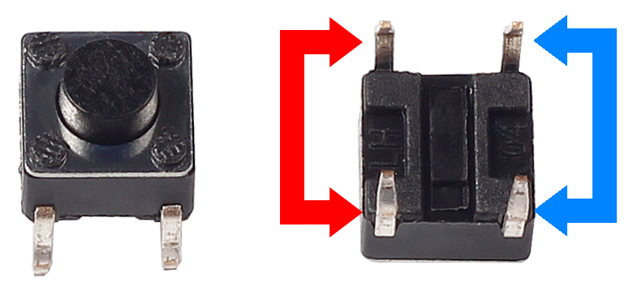

**Front Back**

When the button is pressed, the pins pointed by the blue arrow will connect to the pins pointed by the red arrow (see the above figure), thus closing the circuit, as shown in the following diagrams.

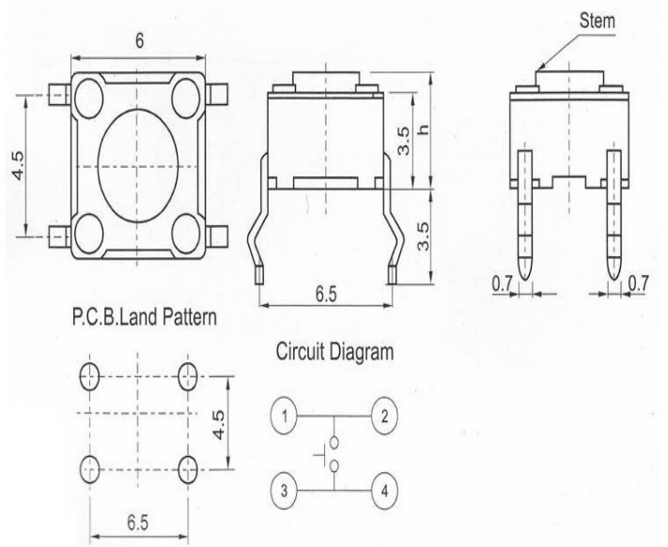

Generally, the button can be connected directly to the LED in a circuit to turn on or off the LED, which is comparatively simple. However, sometimes the LED will brighten automatically without any button pressed, which is caused by various kinds of external interference. In order to avoid this interference, a pull-down resistor is used – usually connect a 1K–10KΩ resistor between the button and GND. It can be connected to GND to consume the interference when the button is off.

This circuit connection is widely used in numerous circuits and electronic devices. We may use the button to control a circuit later in many experiments (in or outside this kit maybe), so you might get its principle, which is very simple, and application at the beginning of your study.

**Experimental Procedures**

**Step 1:** Build the circuit

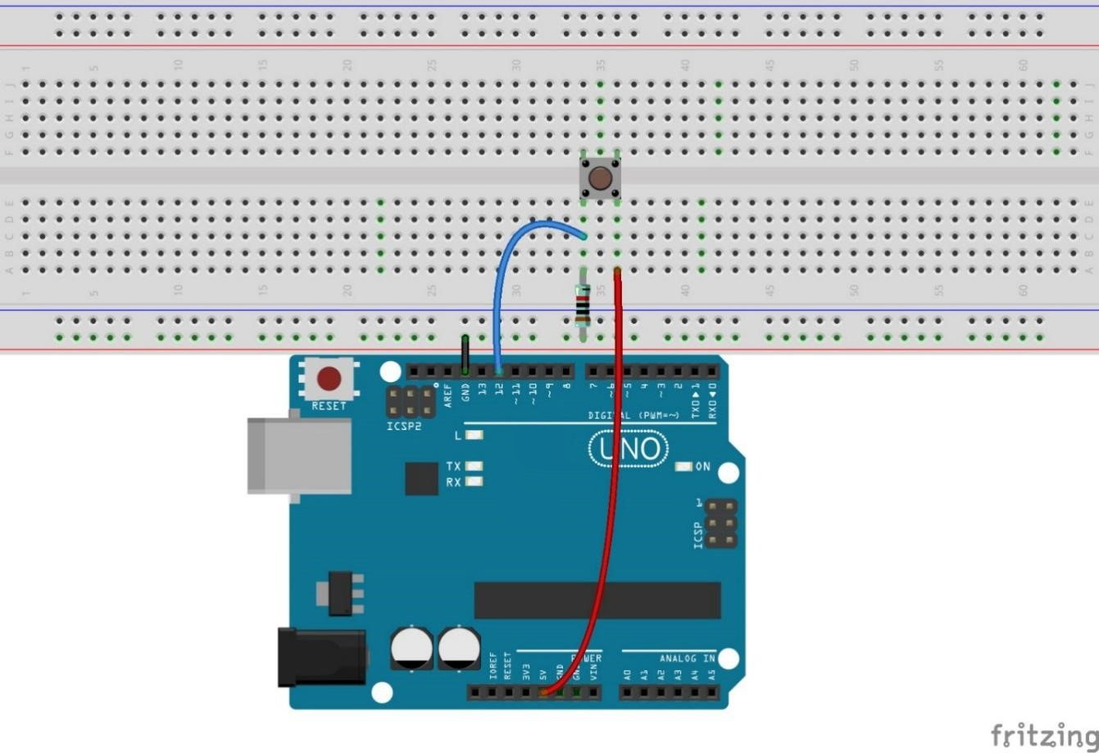

The schematic diagram

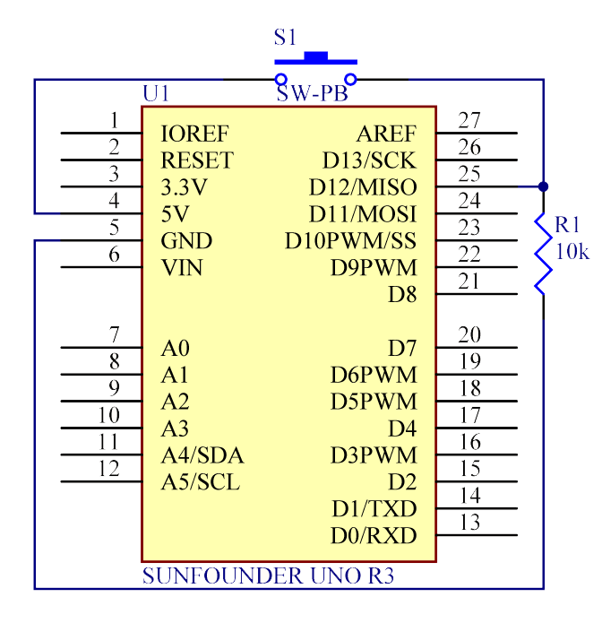

**Step 2:** Program (Please refer to the example code in **Ivolador Starter Kit for Arduino**)

**Step 3:** Compile the code

**Step 4:** Upload the sketch to the Ivolador Uno board

Now, press the button, and the LED on the Ivolador Uno board will light up.

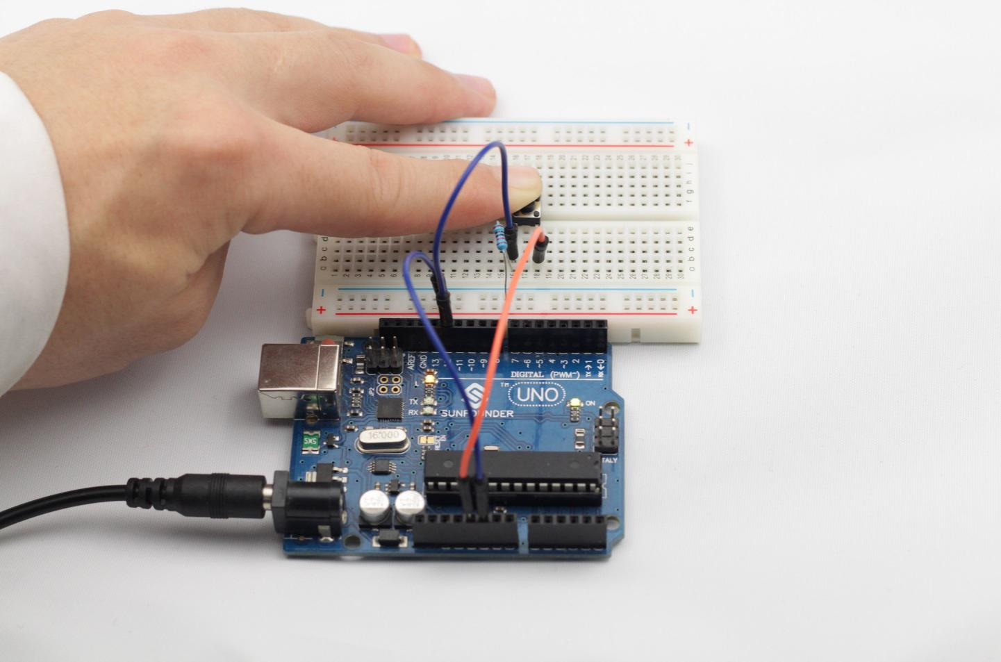

Lesson 2 Flowing LED Lights

**Introduction**

In this lesson, we will conduct a simple yet interesting experiment – using LEDs to create flowing LED lights. As the name suggests, these eight LEDs in a row successively light up and dim one after another, just like flowing water.

**Components**

- 1 \* Ivolador Uno board

- 1 \* Breadboard

- Jumper wires

- 8 \* LED

- 8 \* Resistor (220Ω)

- 1 \* USB cable

**Principle**

The principle of this experiment is simply to turn on eight LEDs in turn.

**Experimental Procedures**

**Step 1:** Build the circuit

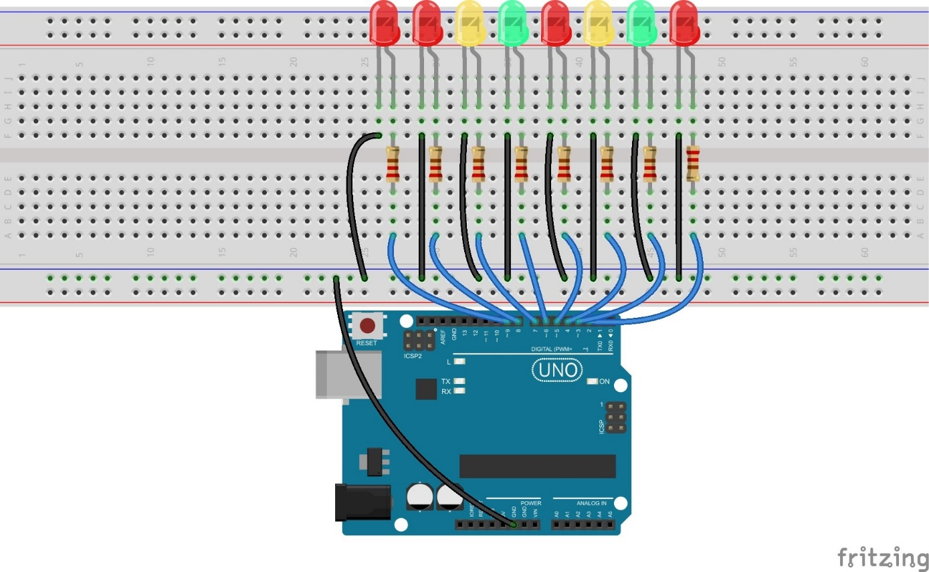

The schematic diagram

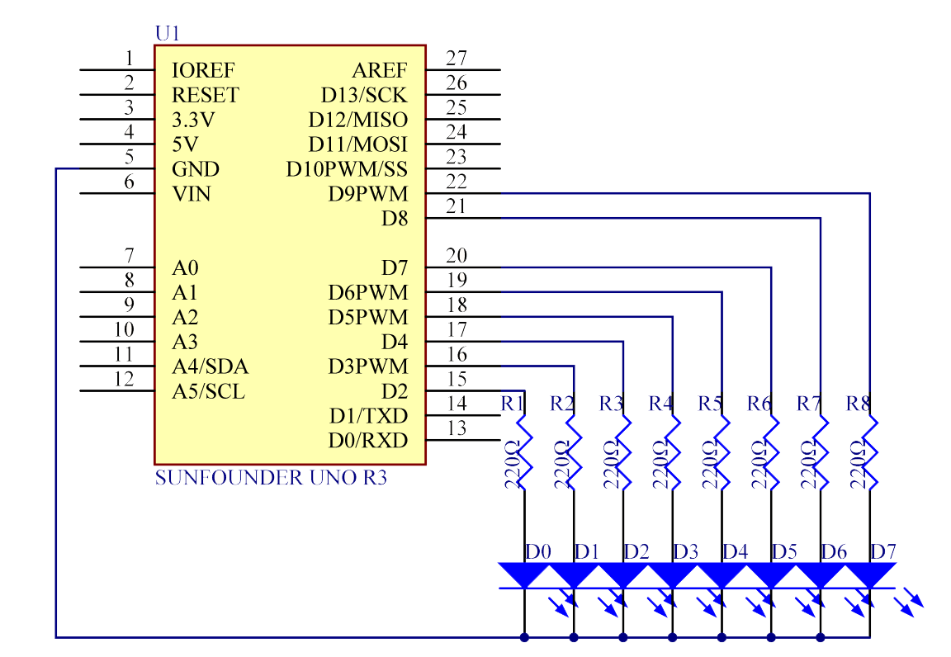

**Step 2:** Program (Please refer to the example code in **Ivolador Starter Kit for Arduino**)

**Step 3:** Compile the code

**Step 4:** Upload the sketch to the Ivolador Uno board

Now, you should see eight LEDs brighten one by one from left to right, and then dim in turn from right to left. After that, the LEDs will light up from right to left and dim from left to right. This whole process will repeat until the circuit is power off.

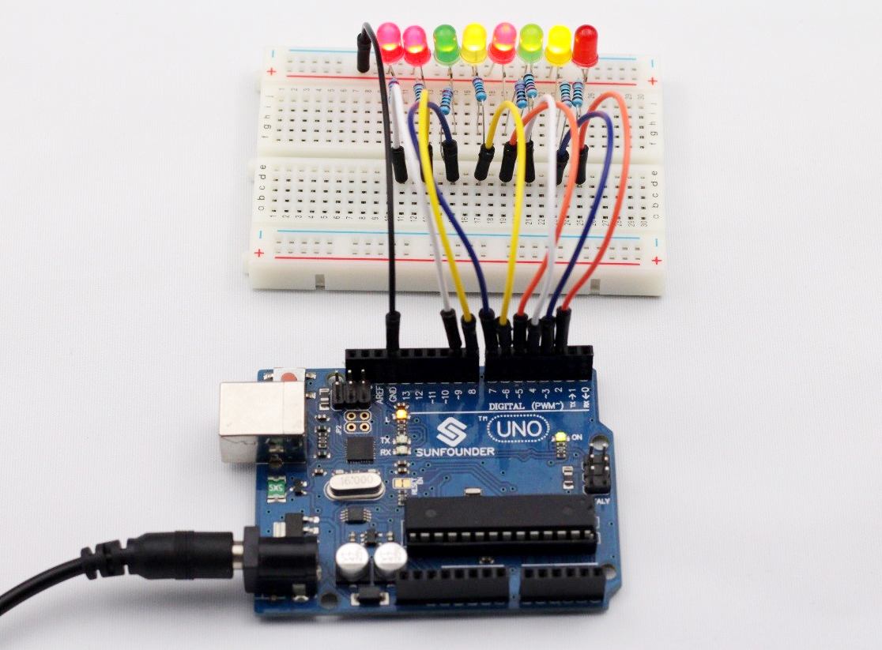

Lesson 3 Controlling an LED by Potentiometer

**Introduction**

In this lesson, we will learn how to change the luminance of an LED by potentiometer.

**Components**

- 1 \* Ivolador Uno board

- 1 \* Breadboard

- Jumper wires

- 1 \* Resistor (220Ω)

- 1 \* LED

- 1 \* Potentiometer

- 1 \* USB cable

**Principle**

**Analog V.S. Digital**

A linear potentiometer is an analog electronic component. So what’s the difference between an analog value and a digital one? Simply put, digital means on/off, high/low level with just two states, i.e. either 0 or 1. But the data state of analog signals is linear, for example, from 1 to 1000; the signal value changes over time instead of indicating an exact number. Analog signals include those of light intensity, humidity, temperature, and so on.

In this experiment, a potentiometer, or pot, is used to change the current in the circuit so the luminance of the LED will change accordingly. And since the pot is an analog device, the current change is smooth, thus the LED will gradually get brighter or dimmer instead of going through an obvious stepwise process. Also it should be connected to analog ports, i.e. A0-A5, instead of digital ports.

**Experimental Procedures**

**Step 1:** Build the circuit

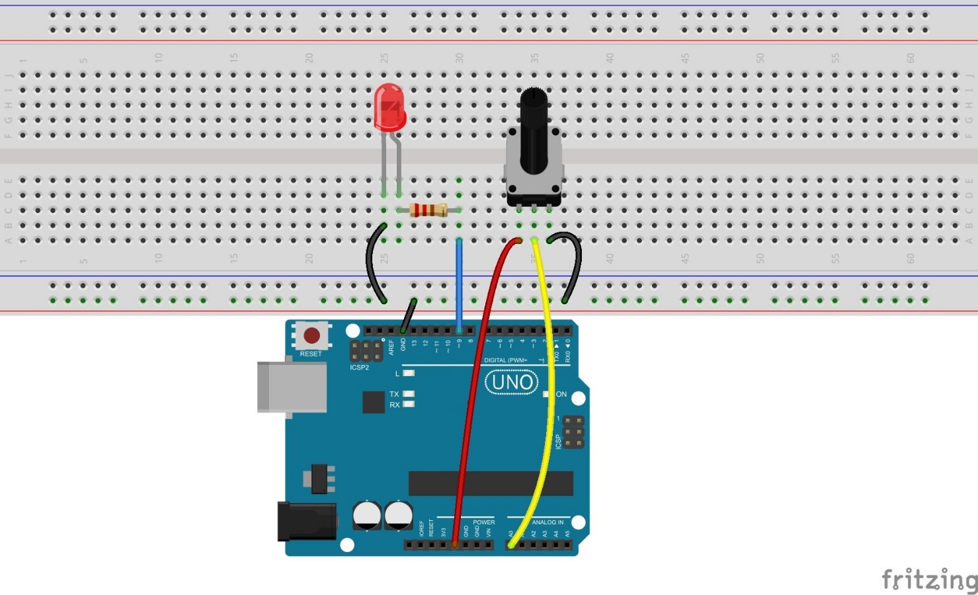

The schematic diagram

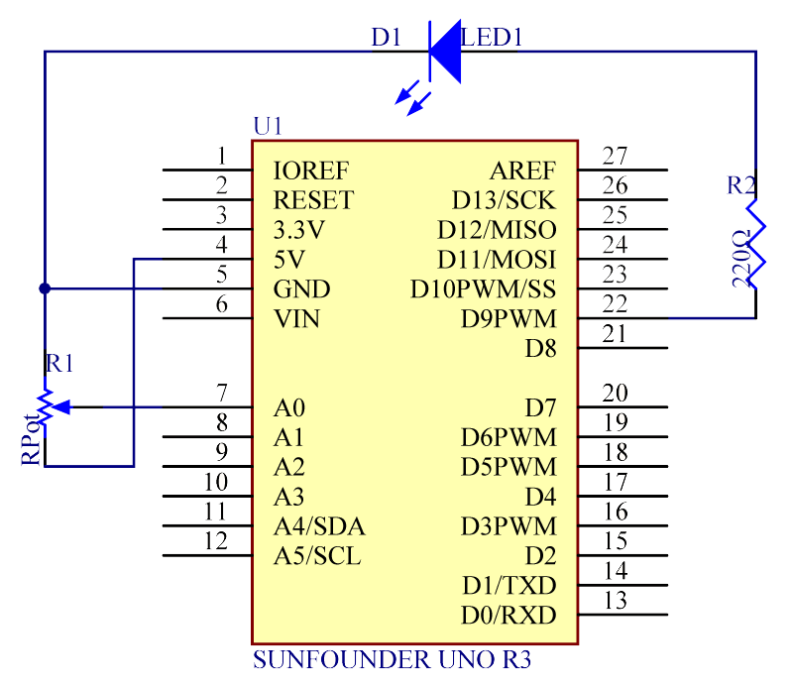

As you see, the potentiometer is connected to pin A0 of the Ivolador Uno board, which can measure voltages from 0V to 5V. The corresponding returned value is from 0 to 1024. The measurement accuracy for voltage change is relatively high.

**Step 2:** Program (Please refer to the example code in **Ivolador Starter Kit for Arduino**)

**Step 3:** Compile the code

**Step 4:** Upload the sketch to the Ivolador Uno board

Spin the shaft of the potentiometer and you can see the luminance of the LED change.

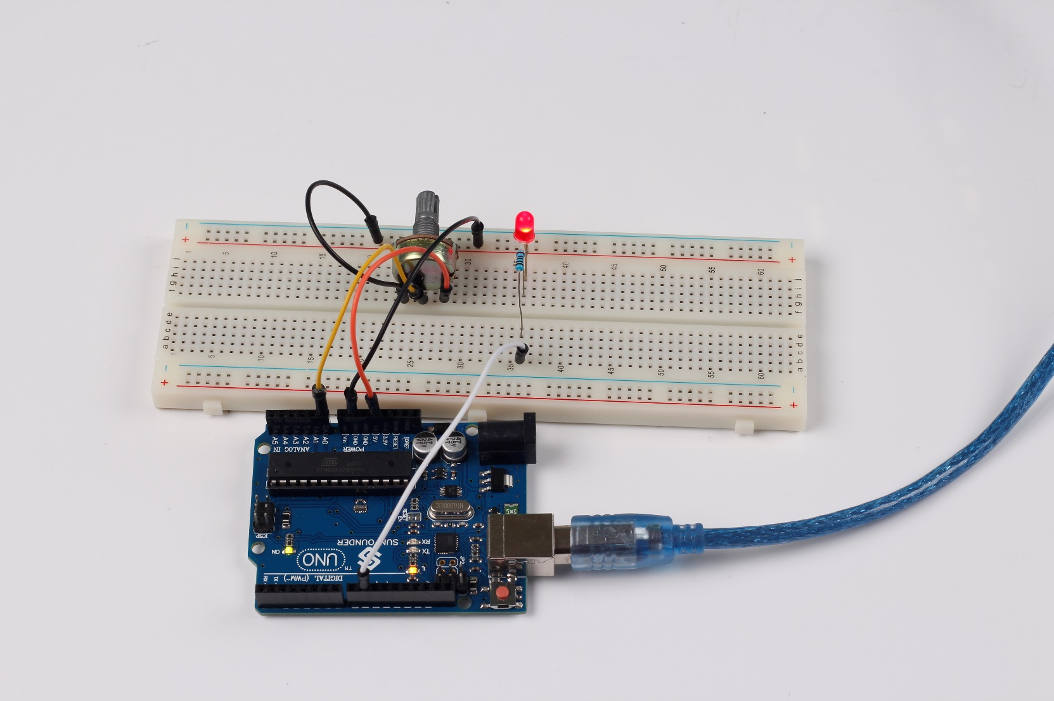

Lesson 4 Buzzer

**Introduction**

A buzzer is a great tool in your experiments whenever you want to make some sounds. In this lesson, we will learn how to drive an active buzzer to beep.

**Experimental Conditions**

- 1 \* Ivolador Uno board

- 1 \* Breadboard

- 1 \* USB data cable

- 1 \* Buzzer (Active)

- Jumper wires

**Principle**

As a type of electronic buzzer with integrated structure, buzzers, which are supplied by DC power, are widely used in computers, printers, photocopiers, alarms, electronic toys, automotive electronic devices, telephones, timers and other electronic products for voice devices. Buzzers can be categorized as active and passive ones (see the following picture). Turn the pins of two buzzers face up, and the one with a green circuit board is a passive buzzer, while the other enclosed with a black tape is an active one.

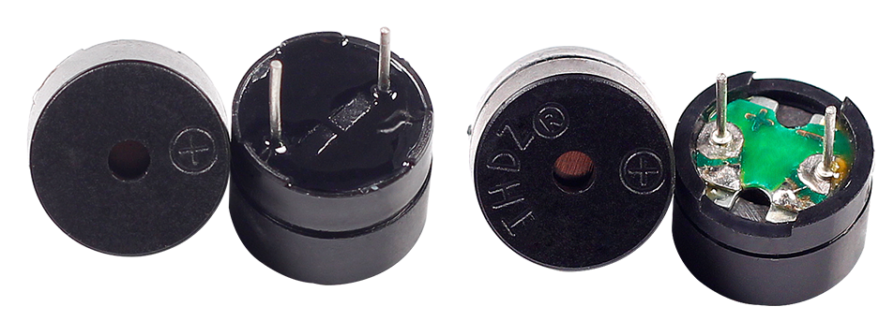

The difference between an active buzzer and a passive buzzer is:

An active buzzer has a built-in oscillating source, so it will make sounds when electrified. But a passive buzzer does not have such source, so it will not tweet if DC signals are used; instead, you need to use square waves whose frequency is between 2K and 5K to drive it. The active buzzer is often more expensive than the passive one because of multiple built-in oscillating circuits.

In this experiment, we use the active buzzer.

**Experimental Procedures**

**Step 1:** Build the circuit (Pay attention to the positive and negative poles of the buzzer)

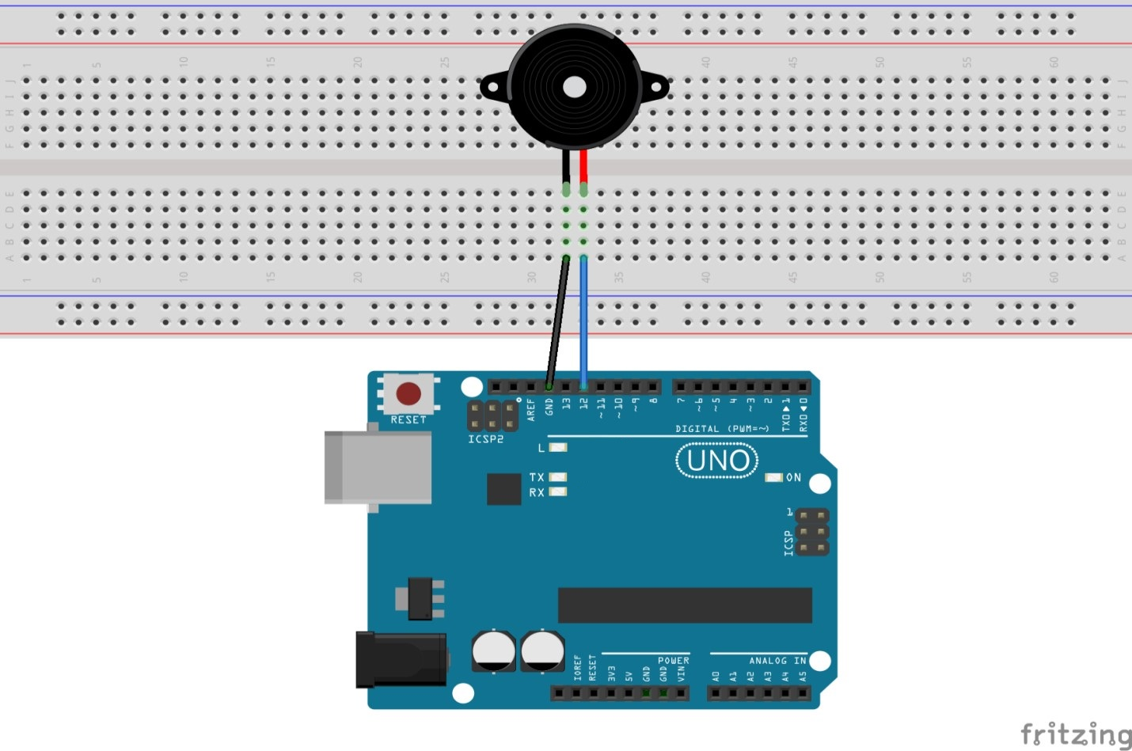

The schematic diagram

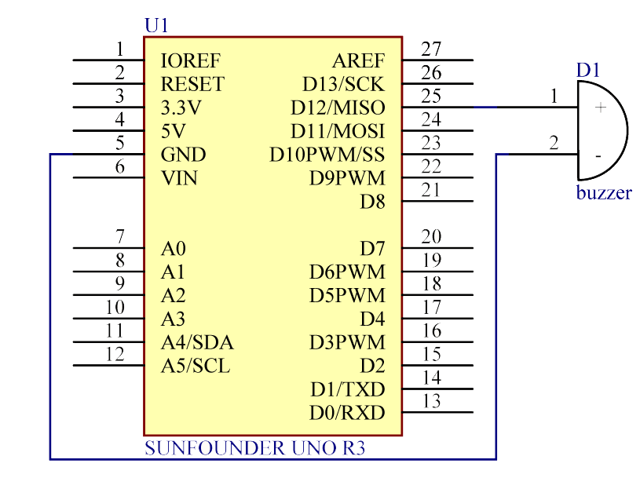

**Step 2:** Program (Please refer to the example code in **Ivolador Starter Kit for Arduino**)

**Step 3:** Compile the code

**Step 4:** Upload the sketch to the Ivolador Uno board

Now, you should hear the buzzer beep.

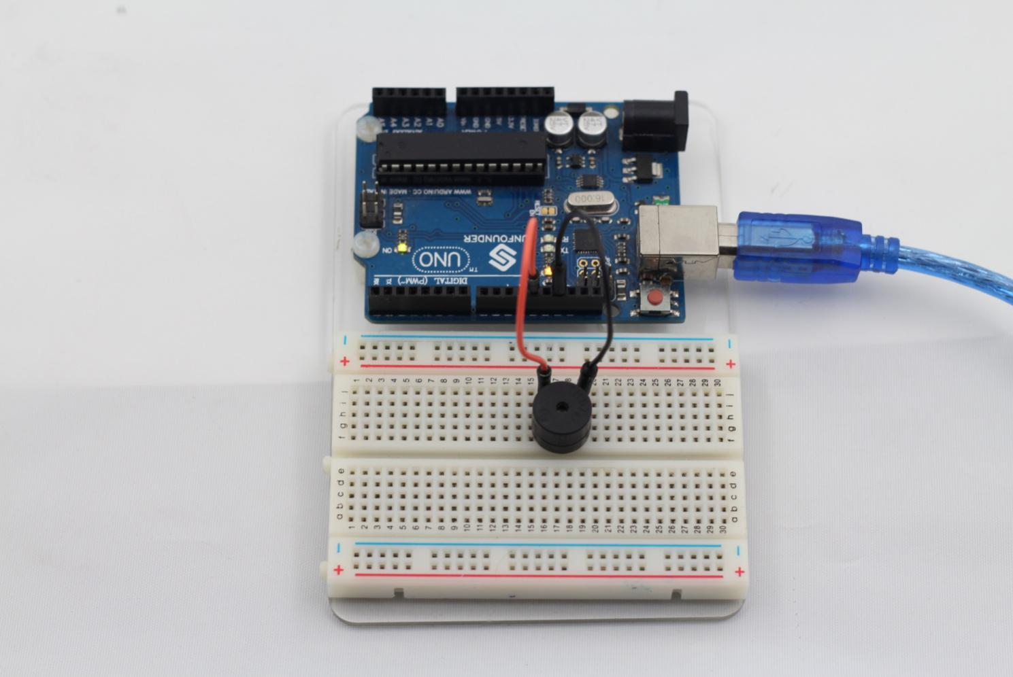

Lesson 5 Photoresistor

**Introduction**

A photoresistor or photocell is a light-controlled variable [resistor](http://en.wikipedia.org/wiki/Resistor). The [resistance](http://en.wikipedia.org/wiki/Electrical_resistance) of a photoresistor decreases with increasing incident light intensity; in other words, it exhibits [photoconductivity](http://en.wikipedia.org/wiki/Photoconductivity). A photoresistor can be applied in light-sensitive detector circuits, and light- and dark-activated switching circuits.

**Experimental Conditions**

- 1 \* Ivolador Uno board

- 1 \* USB data cable

- 1 \* Photoresistor

- 1 \* Resistor (10KΩ)

- 8 \* LED

- 8 \* Resistor (220Ω)

- Jumper wires

-1 \* Breadboard

**Experimental Principle**

The resistance of the photoresistor changes with incident light intensity. If the light intensity gets higher, the resistance decreases; if low, the intensity increases.

In this experiment, we will use eight LEDs to indicate light intensity. The higher the light intensity is, the more LEDs brighten. When the light intensity is high enough, all the LEDs will light up. When there is no light on the sensor, all the LEDs will go out.

**Experimental Procedures**

**Step 1:** Build the circuit

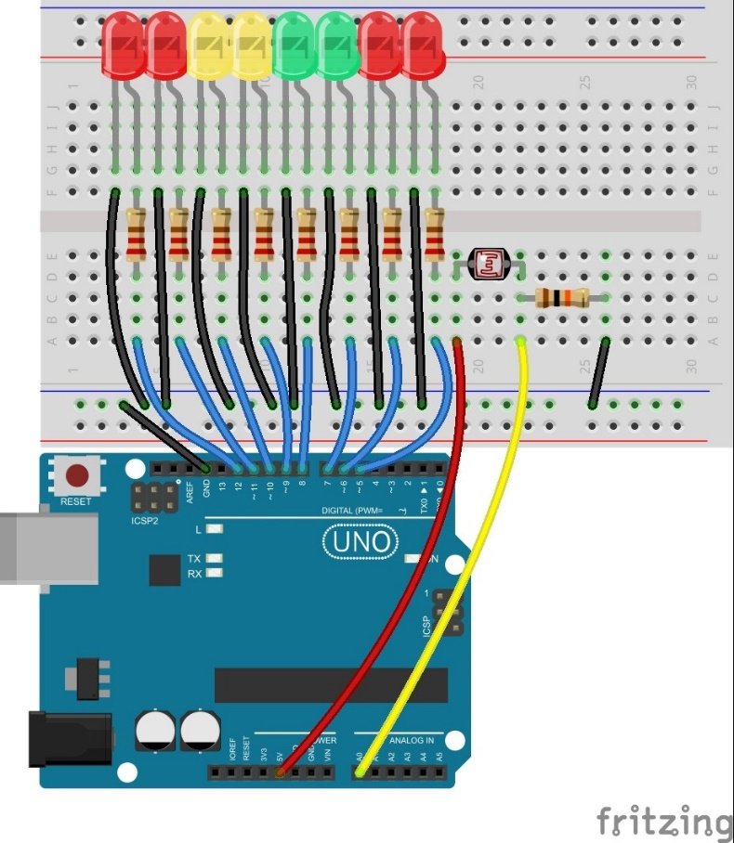

The schematic diagram

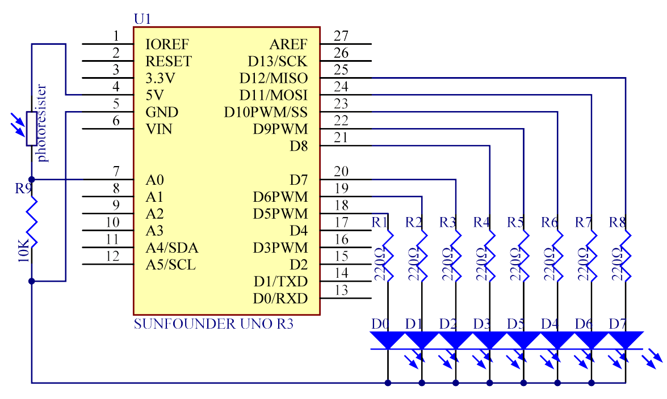

**Step 2:** Program (Please refer to the example code in **Ivolador Starter Kit for Arduino**)

**Step 3:** Compile the code

**Step 4:** Upload the sketch to the Ivolador Uno board

Now, shine a flashlight or other light sources on the photoresistor, and you will see several LEDs light up. Change the light intensity and you will see more (or less) LEDs brighten. Place it in a dark environment, and all the LEDs will go out.

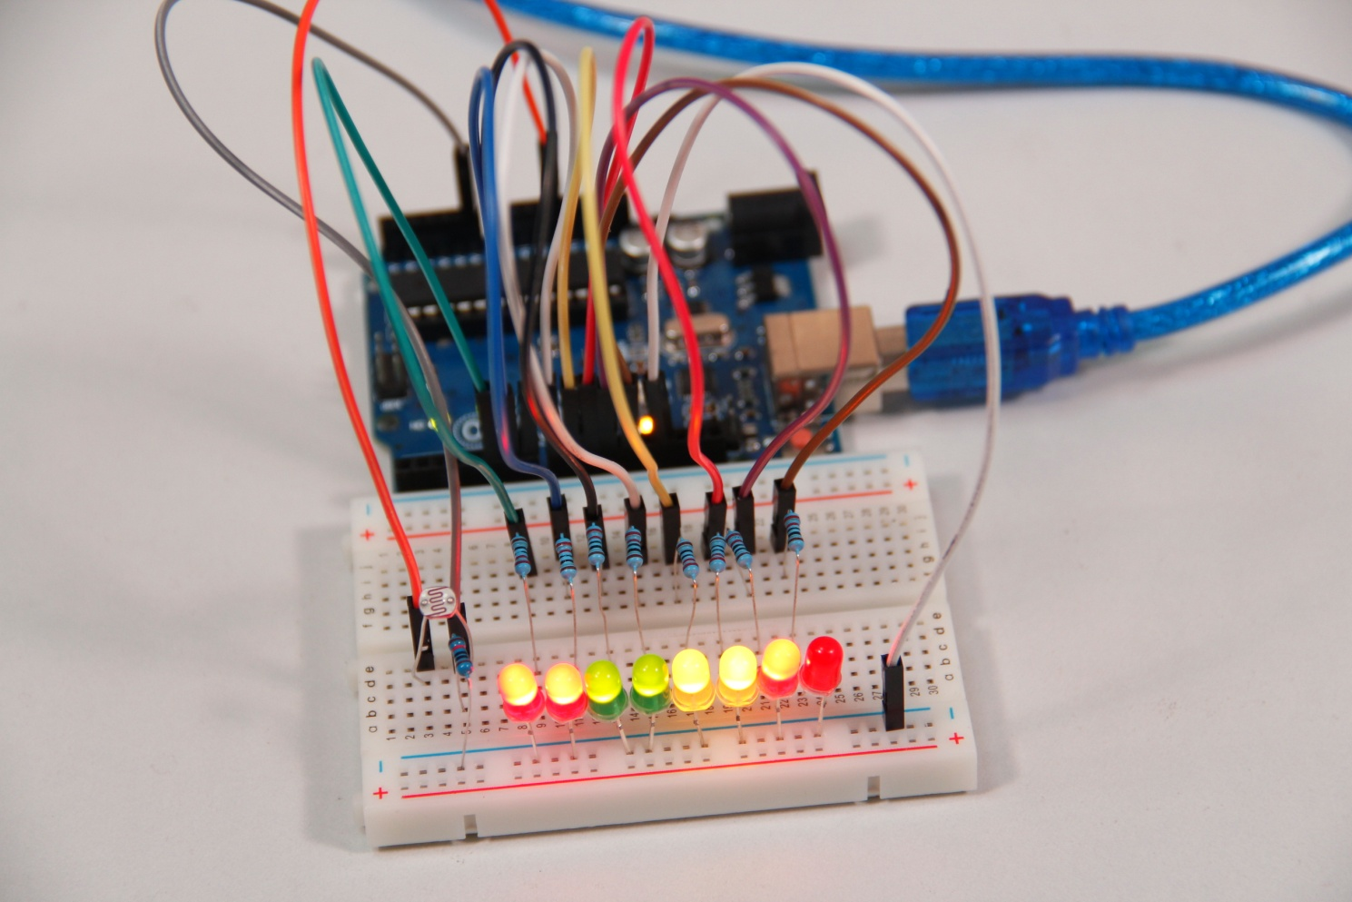

**Exploration**

In addition, you can replace the photoresistor with a microphone and use the LEDs to indicate sound intensity. The higher the sound intensity is, the more LEDs brighten. Try to realize this effect by yourself!

Lesson 6 Servo

**Introduction**

Servo is a type of geared motor that can only rotate 180 degrees. It is controlled by sending electrical pulses from your Ivolador Uno board. These pulses tell the servo what position it should move to.

A servo has three wires, the brown wire is GND, the red one is VCC, and the orange one is signal line.

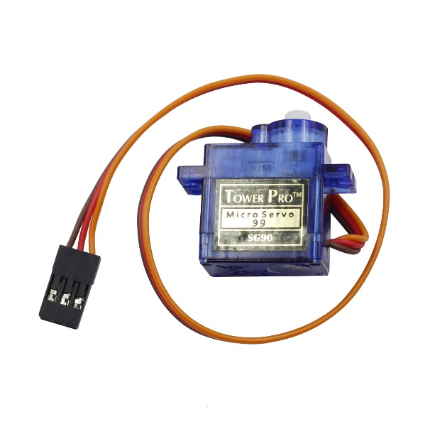

**Components**

**-** 1 \* Ivolador Uno board

- 1 \* USB data cable

- 1 \* Servo

- Several jumper wires

**Experimental Principle**

**Servo**

A servo is generally composed of the following parts: case, shaft, gear train, adjustable potentiometer, DC motor, and control circuit board.

It works like this: The Ivolador Uno board sends out PWM signals to the servo, and then the control circuit in the servo receives the signals through the signal pin and controls the motor inside to turn. As a result, the motor drives the gear chain and then motivates the shaft after deceleration. The shaft and adjustable potentiometer of the servo are connected together. When the shaft rotates, it drives the pot, so the pot outputs a voltage signal to the circuit board. Then the board determines the direction and speed of rotation based on the current position, so it can stop exactly at the right position as defined and hold there.

**Experimental Procedures**

**Step 1**: Build the circuit

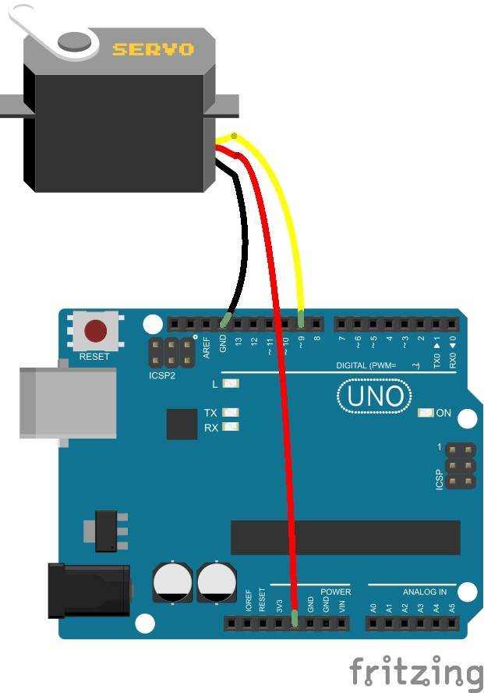

The schematic diagram

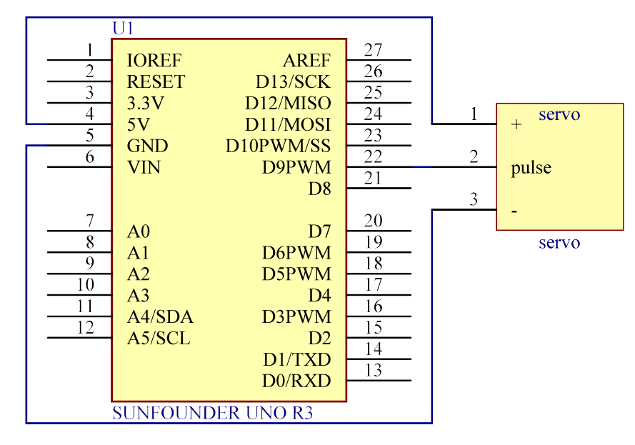

**Step 2:** Program (Please refer to the example code in **Ivolador Starter Kit for Arduino**)

**Step 3:** Compile the program.

**Step 4:** Burn the program into the Ivolador Uno board

Now, you can see rocker arm of the servo spin 90 degrees (5 degrees each time). And then it spins in the opposite direction.

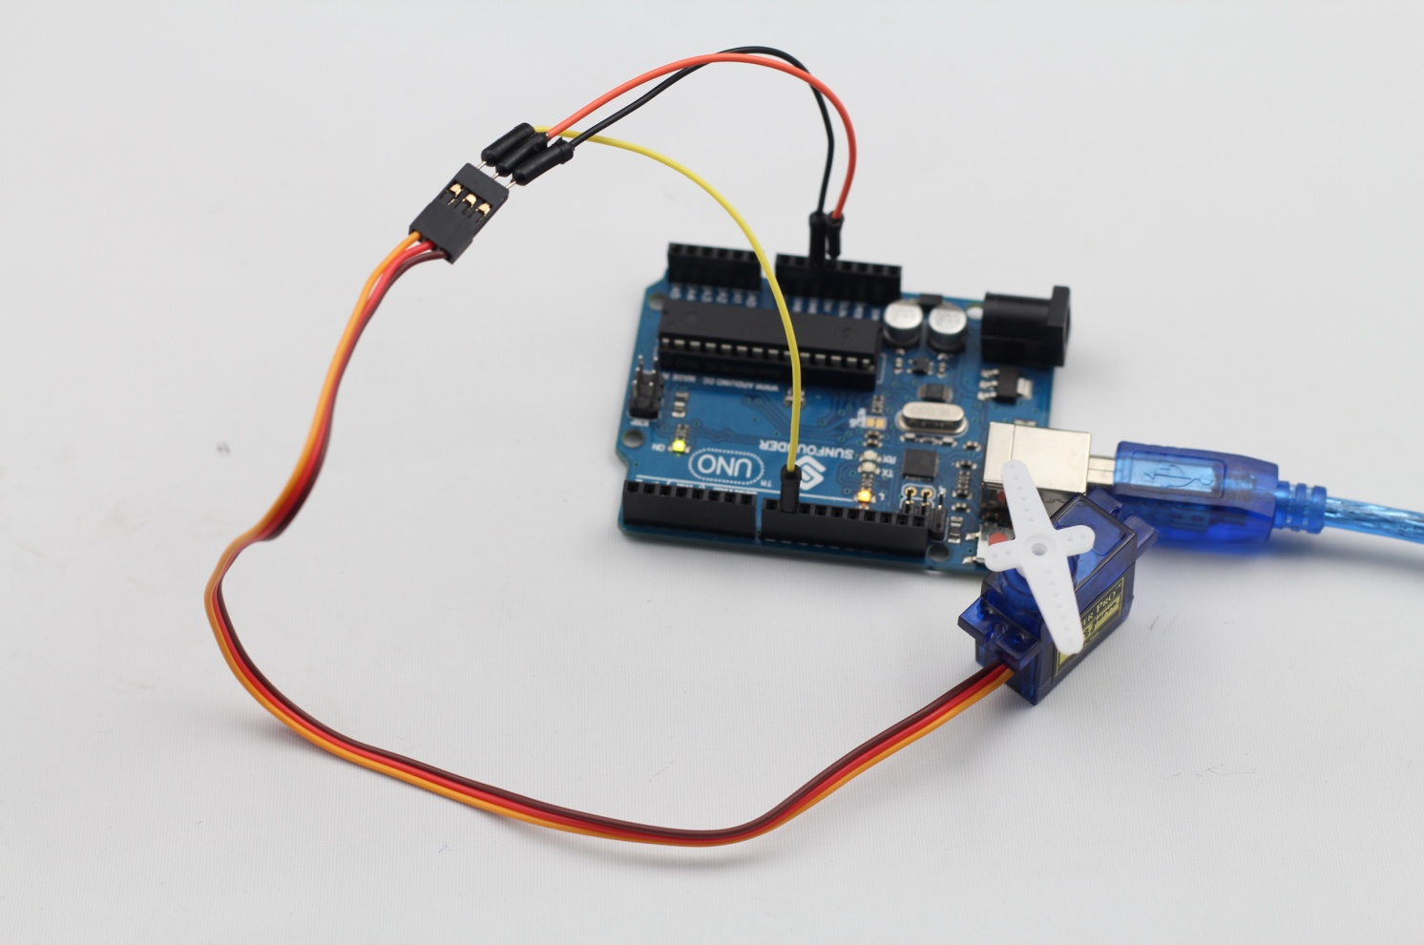

Lesson 7 Tilt-Switch

**Introduction**

The tilt switch used here is a ball one with a metal ball inside. It is used to detect small angle of inclination.

**Components**

- 1 \* Ivolador Uno board

- 1 \* USB data cable

- 1 \* Tilt switch

- Several jumper wires

**Experimental Principle**

The principle is very simple. When the switch is tilted in a certain angle, the ball inside rolls down and touches the two contacts connected to the pins outside, thus triggering circuits. Otherwise the ball will stay away from the contacts, thus breaking the circuits.

**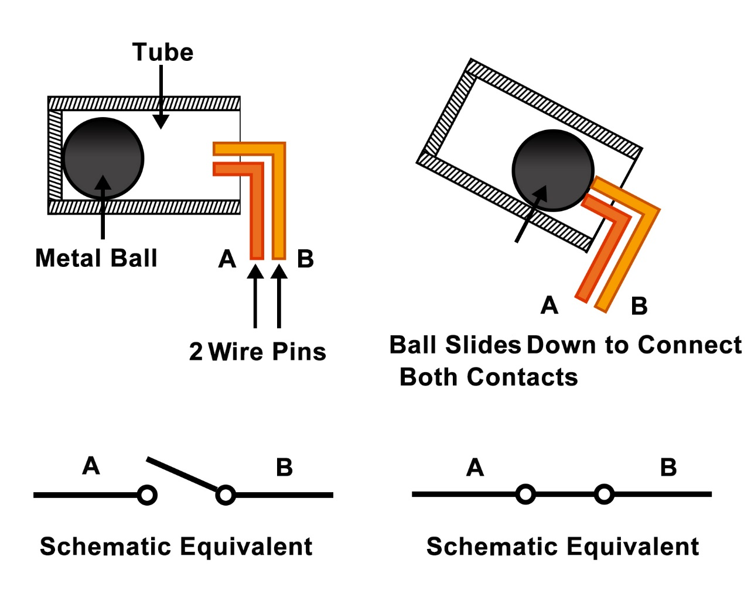**

**Experimental Procedures**

Step 1: Build the circuit

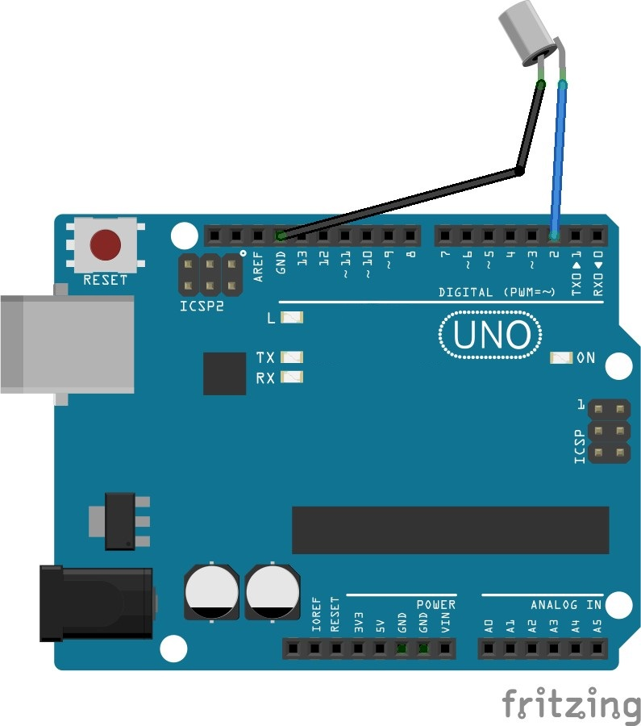

The schematic diagram

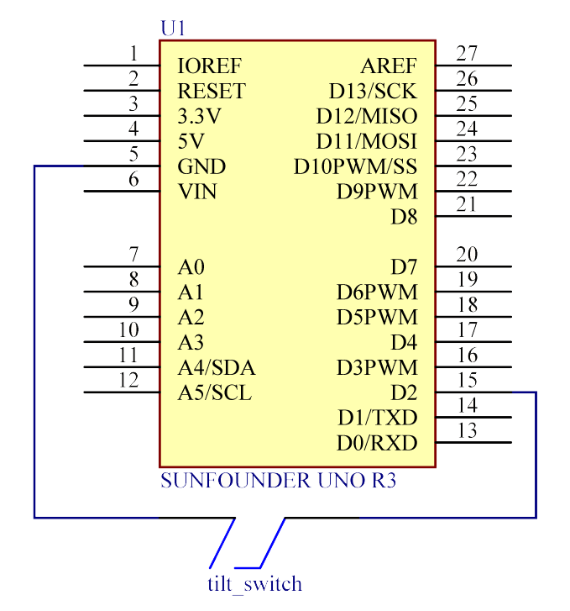

**Step 2:** Program (Please refer to the example code in **Ivolador Starter Kit for Arduino**)

**Step 3:** Compile the code

**Step 4:** Upload the sketch to the Ivolador Uno board

Now, tilt the switch, and the LED attached to pin 13 on Ivolador Uno board will light up.

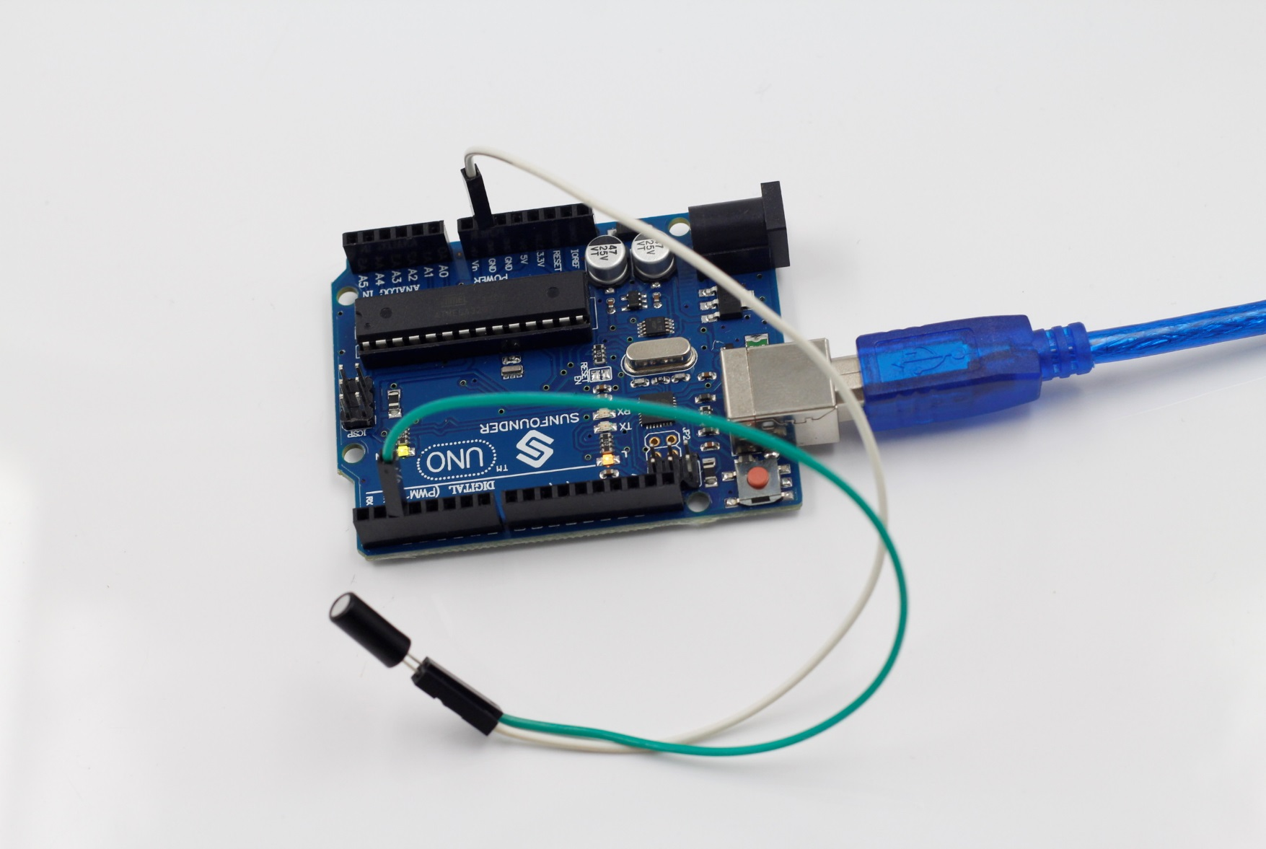

Lesson 8 Light Alarm

**Introduction**

This experiment is a very interesting one – a DIY phototransistor. DIY phototransistors use the glow effect and photoelectric effect of LEDs. That is, LEDs will generate weak currents when some light is shined on it. And we use a transistor to amplify the currents generated, so the Ivolador Uno board can detect them.

**Components**

- 1 \* Ivolador Uno board

- 1 \* Breadboard

- 1 \* USB cable

- Jumper wires

- 1 \* Passive buzzer

- 1 \* Resistor (10KΩ)

- 1 \* LED

- 1 \* NPN Transistor S8050

**Principle**

LEDs not only have a glow effect, but also a photoelectric effect. They will generate weak currents when exposed to light waves.

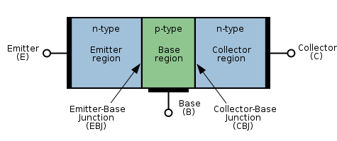

NPN consists of a layer of P-doped semiconductor (the "base") between two N-doped layers (see the picture above). A small current entering the base is amplified to produce a large collector and emitter current. That is, when there is a positive potential difference measured from the emitter of an NPN transistor to its base (i.e., when the base is high relative to the emitter) as well as positive potential difference measured from the base to the collector, the transistor becomes active. In this "on" state, current flows between the collector and emitter of the transistor.

There are three poles for the regions: base (b), emitter (e) and collector (c). They form two P-N junctions, namely the base-emitter junction and collector-base junction. The arrows in the NPN symbol (see the figure below) indicates the direction of the base-emitter junction.

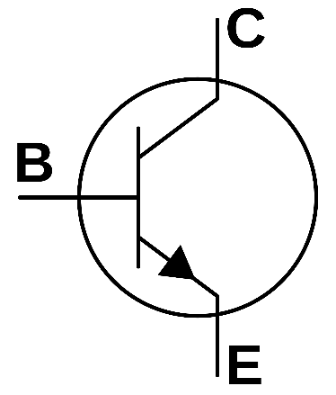

The symbol of NPN is shown here. We can see the two PN junctions with unilateral conductivity inside, which enables it a switch component.

A 10kΩ pull-down resistor is attached to the transistor output stage in order to avoid analog port suspending to interfere with signals and cause misjudgment.

**Experimental Procedures**

**Step 1:** Build the circuit

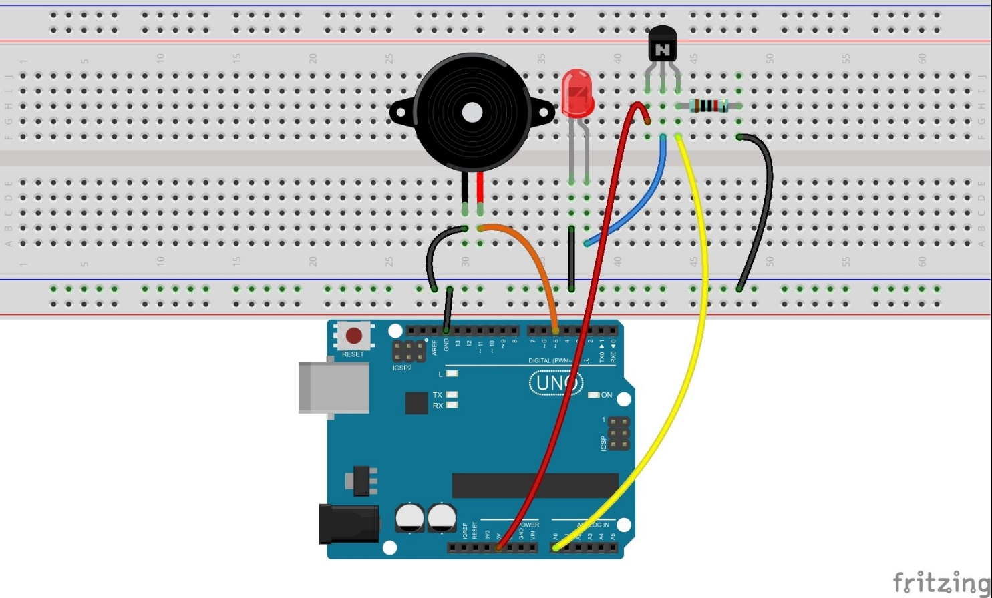

The schematic diagram

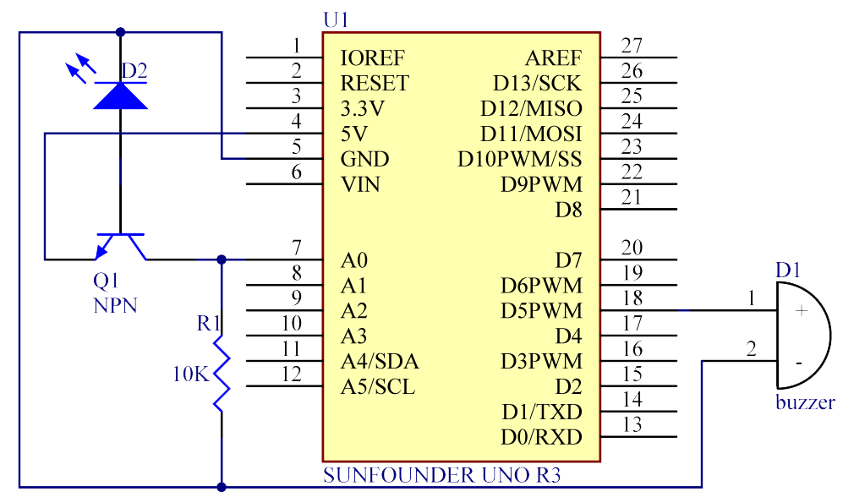

**Step 2:** Program (Please refer to the example code in **Ivolador Starter Kit for Arduino**)

**Step 3:** Compile the code

**Step 4:** Upload the sketch to the Ivolador Uno board

Now, you can hear the buzzer beep when shining a flashlight on the LED.

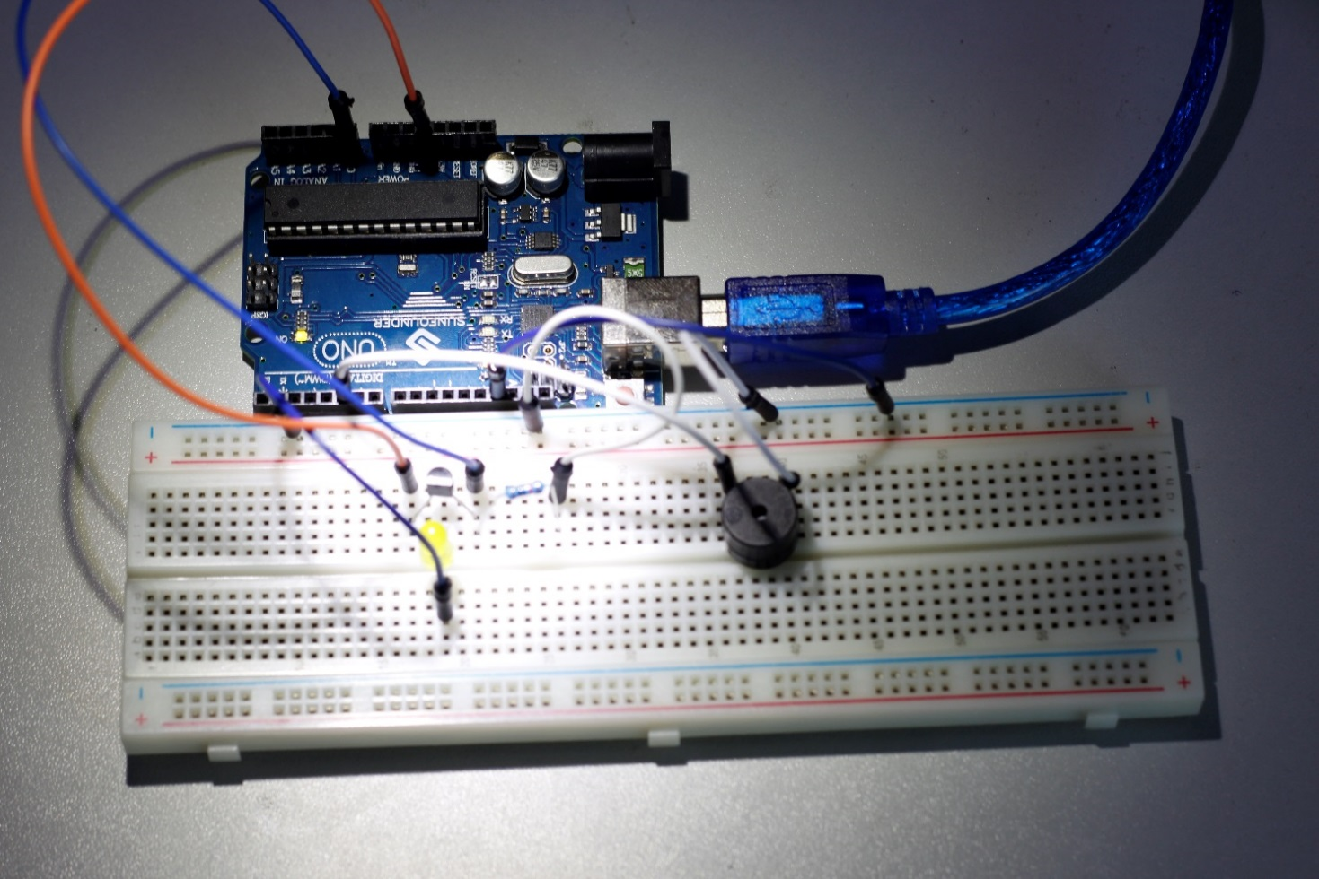

Lesson 9 Automatically Tracking Light Source

**Introduction**

In this lesson, we will make some interesting creations – use a servo motor, a photoresistor and a pull-down resistor to assemble an automatically tracking light source system.

**Components**

**-** 1 \* Ivolador Uno board

- 1 \* Servo motor

- 1 \* Photoresistor

- 1 \* Resistor (10KΩ)

- Several jumper wires

- 1 \* USB data cable

**Experimental Principle**

The rocker arm of the servo and the bundled photoresistor sway together to scan and "look" for light source within 180 degrees and record the location of light source when finding one. Then they stop swaying just at the direction of the light source.

**Experimental Procedures**

**Step 1:** Build the circuit

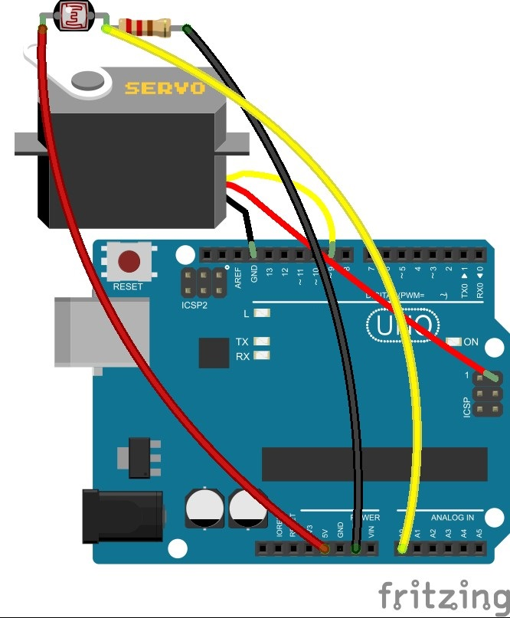

**Note**: you need to bind one end of the resistor and photoresistor to the rocker arm of the servo (cross the pin through the holes of the arm), as shown below:

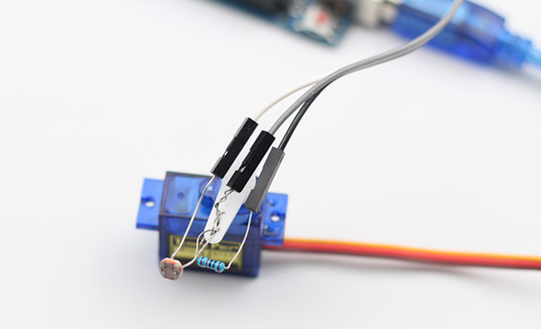

The schematic diagram

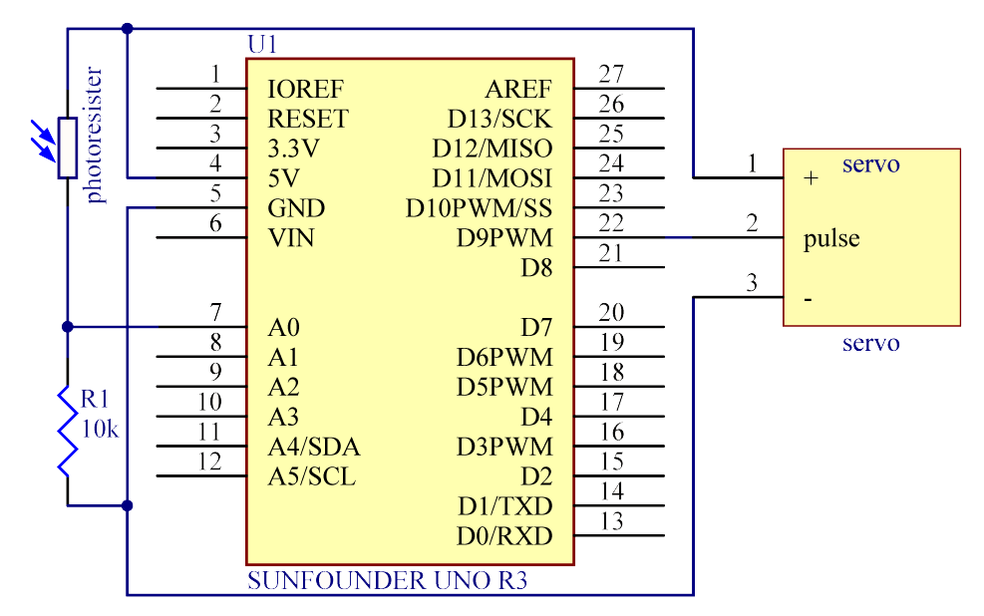

**Step 2:** Program (Please refer to the example code in **Ivolador Starter Kit for Arduino**)

**Step 3:** Compile the program

**Step 4:** Burn the program into the Ivolador Uno board

Now, shine a flashlight onto the photoresistor. Then you will see the rocker arm of the servo and the photoresistor rotate and finally stop at the direction of light source.

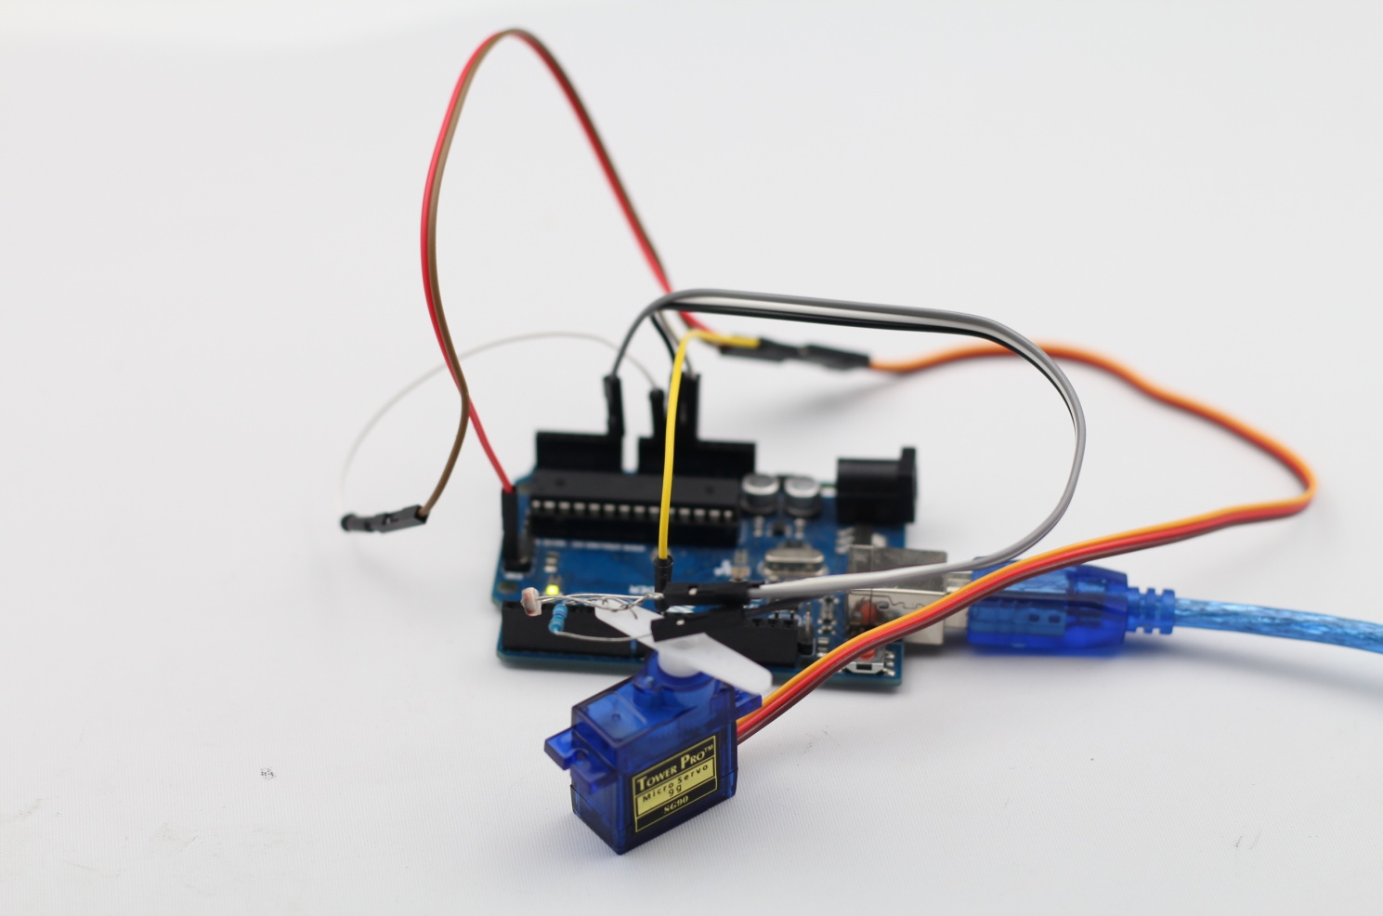

**For Safe Use**

All parts and devices in this kit should be powered appropriately in compliance with relevant regulations and standards applicable in the country of intended use.

The connection of unapproved external devices to the modules/boards in this kit may affect compliance or result in damage to the unit, for which we will not be responsible.

To avoid malfunction or damage to your circuit boards, please observe the following:

DO NOT expose it to water/moisture or place it on a conductive surface whilst in operation.

DO NOT expose it to heat from any source; the product is designed for reliable operation at normal ambient room temperatures.

Take care whilst handling to avoid mechanical or electrical damage to the printed circuit board and connectors.

PLEASE perform the connection or wiring based on the instructions in the manual or our website if you are not clear of the results.